Attendees: Carol Mack, Matt Berger, Mike Lithgow, Alex Laughery, Forrest Ownbey, Adam Gebauer, David Marcell, Matt Hobbs (?)
RTCA Virtual: Steph Stroud, Alex Stone
Phone: Mike Jensen

Welcome and Introductions
- Update: Kalispel DNR applied for funding from conservation district for engineering to design water system for nursery (overflow from pond to nursery). Stay tuned for update about approval.
- Community Forest Plan and meeting notes are now on the Kalispel Tribe website.

Decision Making
Decision making was discussed for the 6-9 month period that this short term advisory committee will be together. A new decision process will be worked out for the organization that manages the Community Forest after this implementation strategy planning process is over.
- Mike shared that as land owners the Kalispel Tribe has ultimate decision making authority, but the AC can use an activity to come to a consensus to advise. Mike brought green, red, and yellow flash cards to use to express agreement/support or lack of support on a decision.
  - Green=Agree
  - Red= Don’t agree
  - Yellow= Not ideal, will support
  - We can use the flashcards to express ourselves from now on!

Vision and Mission Statements: Recruiting Poets and Artists!
A Vision statement is a description of a shared future state; what the future will look and feel like.
A Mission statement describes the organization created to achieve the Vision. Goals are steps taken by the organization to achieve the Mission.
- The group discussed the value of having a vision statement
- The group reviewed two RTCA projects and their Vision/Mission Statements—one from a park prescription program in Bellingham and the Concrete Trails System in Concrete, WA.
- We reviewed some of the language that came from our last meeting’s brainstorming exercise. Some recurring themes include hands-on education, a destination or overnight facility for groups, web-based resources for educators, a community resource to connect local experts, connecting families to the forest and tradition, job training, logging rescue, fire dept training, hiking/outdoor recreation, a place for all ages, clean air and water, positive lifestyle choices, and a place for improved mental and physical health.
- Reaching out for volunteers to craft vision and mission statements—Mike Jensen and David Marcell have volunteered. Thank you!
- Another local resource for a Vision/Mission is the Dishman Hills Conservancy.

Timeline and Workplan: Reviewed proposed timeline and work plan:

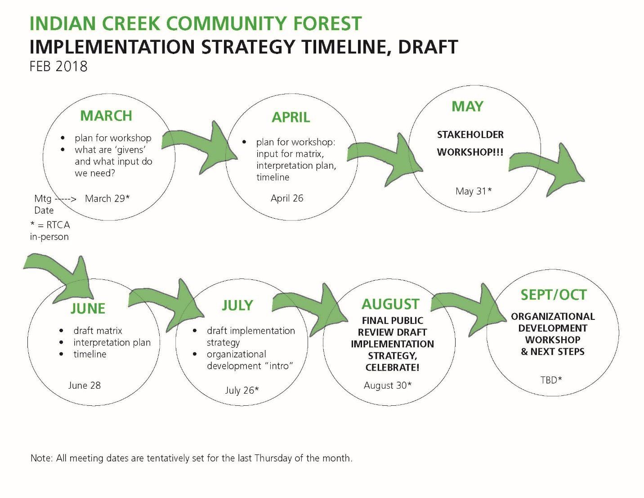
- How to build community connections/networking into the process as we go?

- Most important date: Stakeholder/community workshop to be held in May.
  - Purpose & outcome? (engage community, raise awareness & input on aspects of programs and management that we control)
  - Discussed how it was important to go above and beyond to advertise workshop to make sure a lot of people know about it.
  - Recently there has been an increase of new environmental groups in the community due to proposed smelter facility
  - Possibility of creating a workshop brochure
  - Could hold the workshop at the Camas Center—could capture parents with children at day care during the day, and teachers and students at night
  - Potential drone footage for workshop?
  - Share the givens & expectations (what’s already planned for Community Forest, “the box”, where are we starting from)?
  - Will want to reach out to stakeholders we identified at last meeting
  - Youth engagement component (NPS can visit classrooms if need be)
  - Potential tribal participation?
  - Ideas to discuss at workshop: potential opportunities for studies, programs to support citizen science
  - How can we make this an appealing workshop?
    - Incentives for participants: free passes to Camas Center or other paid stipend?
    - Do we need to provide accommodations (best time of day, food, childcare, translation, etc.)?
      - Speakers, presenters?
        - Lucas (tree climber) is energetic and has expressed interest

Next Steps based on Timeline
- Save the dates for upcoming AC Meetings (Last Thursdays):
  - March 29 (RTCA in person)
    - Draft of Vision and Mission statements from Mike and David
    - Brainstorm ideas for publicity of workshop
    - Discuss potential presentation from Lucas (tree climber)
    - Gary (graphic designer) to discuss Community Forest logo, color scheme, fonts
    - Continue planning for workshop
  - April 26
    - Plan for workshop
    - Graphic design update
  - May 31 (RTCA in person) STAKEHOLDER WORKSHOP
    - Gather input for CF, interpretation/storytelling
    - Youth engagement?
    - Refine graphic design?
  - June 28 – Maybe held at Indian Creek
    - Use feedback from the workshop to create a draft matrix for CF
    - Draft Interpretation plan
    - Drafting funding plan
    - Draft timeline
  - July 26 (RTCA in person)—Maybe held at Indian Creek
    - Draft implementation strategies
    - 1 hour intro into organizational development (what will the organization look like going forward?)
  - August 30 (BBQ, RTCA in person)—Held at Indian Creek (May not have DNR)
    - Finalize implementation strategy
    - Celebrate with BBQ!
    - Showcase of public review draft
    - Engage the community/stakeholders
  - Sept/Oct (RTCA in person)
    - Organization going forward

Good of the Order (10 mins) All
- Larger community events and updates
  - North American Environmental Education Conference in Spokane

