February 12, 2018
Governor Jay Inslee
Office of the Governor
PO Box 40002
Olympia, WA 98504-0002
Re: Opposition to the HiTest Silicon Smelter in Newport, WA

Dear Governor Inslee:
I write on behalf of our Tribe as we were disappointed to hear that your Administration is considering supporting a proposal by HiTest Sands, Inc., a Canadian corporation, to construct a silicon smelter in Eastern Washington. We believe that support for this smelter is inconsistent with your values of respecting the sovereignty Tribes and protecting the environment.

We have been informed by the Kalispel Tribe that according to HiTest’s data, the smelter would emit 320,000 tons of greenhouse gases, 760 tons of sulfur dioxide, and 700 tons of nitrogen oxides each year. The smelter would become the state’s 15th largest emitter of greenhouse gases and produce roughly the same amount of sulfur dioxide as 165,000 woodstoves burning continuously at the project site. The smelter would be located approximately 10 miles from the Kalispel Indian Reservation, which means that Kalispel people and children would be exposed to this air pollution 24 hours a day, 7 days a week for the rest of their lives. It is unacceptable to force this level of pollution burden on anybody. Based on these facts, if true, we support the Kalispel Tribe in their opposition of the development of the HiTest silicon smelter.

It is our understanding that your Administration decided to designate this smelter a Project of Statewide Significance without first consulting the Kalispel Tribe even though the smelter was then slated to be built less than a mile upwind of the Kalispel Reservation. We feel that consistent with our Accord Gov’t-to-Gov’t principles you must consult with any Tribe affected by an Executive decision. We urge you to not support this project and you have to rescind the designation of the smelter as a Project of Statewide Significance. We agree that this label is not fitting for a project that would directly harm an Indian Tribe’s interests.

Governor, you have been clear in your intentions to make Washington a leader in clean air and energy. HiTest’s smelter in Newport cannot be part of the zero-emissions future you are working so diligently to create. We hope you will stand with the Tribes in protecting both our peoples and our environment by opposing the HiTest smelter and ordering your agencies to subject the smelter to rigorous environmental review if HiTest chooses to move forward with the project. We are always open to discuss these matters, but we will follow the lead of our sister Tribe.

Sincerely,
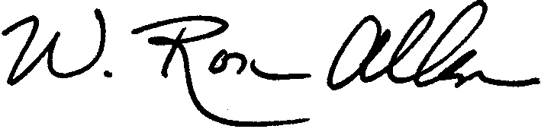
W. Ron Allen, Tribal Chair/CEO

Cc: Kalispel Tribe

